Chapter 2 Problem 50

Design a problem to help other students better understand wye-delta transformations using Fig. 2.114.
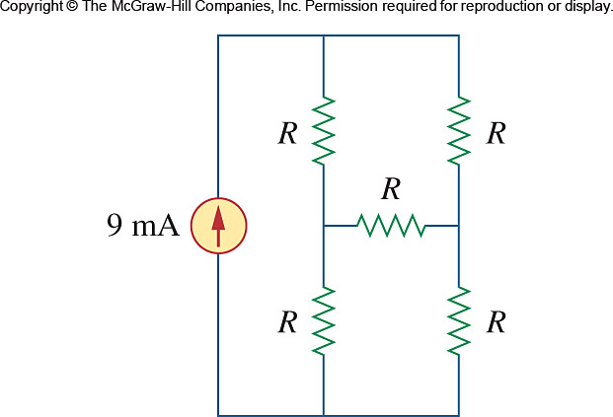

Figure 2.114
For Prob. 2.50.

